Virtual Data Science with Python Apprentice Intern
Week 1 Report
Data Acquisition, Cleaning, and Exploratory Analysis
Dataset: Titanic passenger data (Kaggle)
Tools: Python, Pandas, Seaborn, Matplotlib
Prepared by: Vandana

1. Introduction
Every data science project begins with the same foundation: getting hold of data, understanding what it contains, cleaning it, and exploring it before any modeling or statistical testing is attempted. This report documents that process for Week 1 of the internship, from data acquisition through cleaning to exploratory data analysis (EDA), using Python.
The dataset chosen is the well-known Titanic passenger dataset. It records details of 891 passengers on the ship’s maiden voyage, including whether each person survived. It was chosen for three reasons. It is publicly available and widely used, so results can be checked by anyone. It contains realistic data quality problems (missing values in several columns), which makes the cleaning stage meaningful. It also mixes numeric and categorical variables, which supports a range of visualizations.
The objectives of this week are:
- Acquire a publicly available dataset and load it with Python.
- Clean the data by handling missing values, removing duplicates, and correcting data types, and justify each decision.
- Explore the data using summary statistics and at least three visualizations.
- Summarize the patterns observed and identify areas for further analysis.

2. Data Acquisition
The data comes from the public Titanic passenger dataset published on Kaggle, downloaded as a CSV file (Titanic-Dataset.csv) and loaded into a Pandas Data Frame. The file contains 891 rows (one per passenger) and 12 columns.

2.1 Data dictionary
Column | Type | Description
PassengerId | Integer | Unique passenger identifier
Survived | Integer (0/1) | Target outcome: 0 = did not survive, 1 = survived
Pclass | Integer (1–3) | Ticket class, a proxy for socio-economic status
Name | Text | Passenger name including title
Sex | Text | male or female
Age | Float | Age in years
SibSp | Integer | Number of siblings or spouses aboard
Parch | Integer | Number of parents or children aboard
Ticket | Text | Ticket number
Fare | Float | Fare paid
Cabin | Text | Cabin number
Embarked | Text | Port of embarkation: C = Cherbourg, Q = Queenstown, S = Southampton

2.2 Loading and first inspection
The data was loaded and inspected with the following code. The inspection checks the shape, data types, missing values, duplicates, and basic statistics before any changes are made.
import pandas as pd
import seaborn as sns
import matplotlib.pyplot as plt

df = pd.read_csv('Titanic-Dataset.csv')
print("Shape:", df.shape)
print(df.head())
df.info()
print(df.isnull().sum())
print("Duplicates:", df.duplicated().sum())
print(df.describe())

3. Data Cleaning
The initial inspection showed three data quality issues to address and no duplicate rows. Each issue and the reasoning behind the chosen fix is described below.
Issue | Count | Action | Rationale
Age missing | 177 (19.9%) | Fill with median (28.0) | Age is right-skewed, so the median is more robust than the mean. Dropping 20% of passengers would lose too much data.
Embarked missing | 2 (0.2%) | Fill with mode (S) | A categorical variable with only two gaps. The most frequent port is the safest neutral choice.
Cabin missing | 687 (77.1%) | Drop column | Too sparse to impute reliably. Filling this much data would mean inventing values.
Duplicate rows | 0 | Check and remove | None found, but the check is a standard step and is documented for completeness.
Data types | 4 columns | Convert to category | Survived, Pclass, Sex, and Embarked are labels, not quantities, so treating them as categories is more accurate.

3.1 Why median instead of mean for Age
The median age is 28.0 while the mean is 29.7, which indicates a mild right skew (skewness of about 0.51 after imputation). Filling with the median keeps the centre of the distribution stable and avoids being pulled by the small number of older passengers (the maximum age is 80). The mean age after imputation is 29.36, so overall the distribution is only slightly changed.

3.2 Why drop Cabin
Cabin is missing for 687 of 891 passengers. At this level of missingness, any imputation would be mostly guesswork and could introduce misleading patterns. Dropping the column is more honest than filling it. A possible future improvement is to keep a simple “cabin recorded or not” flag, since the presence of a cabin record may itself carry information (see Section 7).

3.3 Cleaning code
# Age: 177 missing -> median imputation
df['Age'] = df['Age'].fillna(df['Age'].median())

# Embarked: 2 missing -> mode imputation
df['Embarked'] = df['Embarked'].fillna(df['Embarked'].mode()[0])

# Cabin: 687 missing (~77%) -> drop column
df = df.drop(columns=['Cabin'])

# Duplicates: check and remove (none found)
df = df.drop_duplicates()

# Correct data types
for col in ['Survived', 'Pclass', 'Sex', 'Embarked']:
df[col] = df[col].astype('category')

After cleaning, a re-check of missing values returned zero missing entries in all remaining columns, so the dataset is ready for exploration.

4. Exploratory Data Analysis

4.1 Summary statistics
Summary statistics for the numeric columns, computed on the raw data before imputation, are shown below.
Variable | Mean | Std | Min | Median | Max | Count
Age | 29.70 | 14.53 | 0.42 | 28.00 | 80.00 | 714
Fare | 32.20 | 49.69 | 0.00 | 14.45 | 512.33 | 891
SibSp | 0.52 | 1.10 | 0 | 0 | 8 | 891
Parch | 0.38 | 0.81 | 0 | 0 | 6 | 891
Pclass | 2.31 | 0.84 | 1 | 3 | 3 | 891
Survived | 0.38 | 0.49 | 0 | 0 | 1 | 891

Key observations from the table:
- Survival: the mean of Survived is 0.38, so 38.4% of passengers survived and 61.6% did not.
- Fare: the mean fare (32.20) is more than double the median (14.45), and the maximum is 512.33. This signals a heavily right-skewed variable (skewness about 4.8) with a small number of very expensive tickets.
- Family variables: the median for both SibSp and Parch is 0, so most passengers travelled alone.
- Class: the median Pclass is 3. In total, 491 passengers were in 3rd class, 216 in 1st, and 184 in 2nd.

4.2 Group comparisons
Survival rates were compared across passenger groups (calculated with a Pandas groupby on the cleaned data):
Group | Passengers | Survival rate
Female | 314 | 74.2%
Male | 577 | 18.9%
1st class | 216 | 63.0%
2nd class | 184 | 47.3%
3rd class | 491 | 24.2%

5. Visualizations
Four visualizations were created using Seaborn and Matplotlib, covering missing values, distributions, group differences, and correlations. The code that generates all four is below, followed by each chart with an interpretation.
# Visualization 1: age distribution
plt.figure(figsize=(8, 5))
sns.histplot(df['Age'], kde=True, bins=30)
plt.title('Age Distribution of Passengers')
plt.savefig('w1_viz1_age_distribution.png', dpi=150, bbox_inches='tight')
plt.close()

# Visualization 2: missing values (drawn from the RAW data)
raw = pd.read_csv('Titanic-Dataset.csv')
plt.figure(figsize=(9, 5))
sns.heatmap(raw.isnull(), cbar=False, cmap='viridis')
plt.title('Missing Values in Raw Data (yellow = missing)')
plt.savefig('w1_viz2_missing_values.png', dpi=150, bbox_inches='tight')
plt.close()

# Visualization 3: fare by survival
plt.figure(figsize=(8, 5))
sns.boxplot(x='Survived', y='Fare', data=df)
plt.title('Fare Distribution by Survival Outcome')
plt.savefig('w1_viz3_fare_by_survival.png', dpi=150, bbox_inches='tight')
plt.close()

# Visualization 4: correlation heatmap
num = df[['Age', 'Fare', 'SibSp', 'Parch']].copy()
num['Survived'] = df['Survived'].astype(int)
num['Pclass'] = df['Pclass'].astype(int)
plt.figure(figsize=(8, 6))
sns.heatmap(num.corr(), annot=True, cmap='coolwarm', fmt='.2f')
plt.title('Correlation Heatmap')
plt.savefig('w1_viz4_correlation.png', dpi=150, bbox_inches='tight')
plt.close()

5.1 Visualization 1: Missing values map
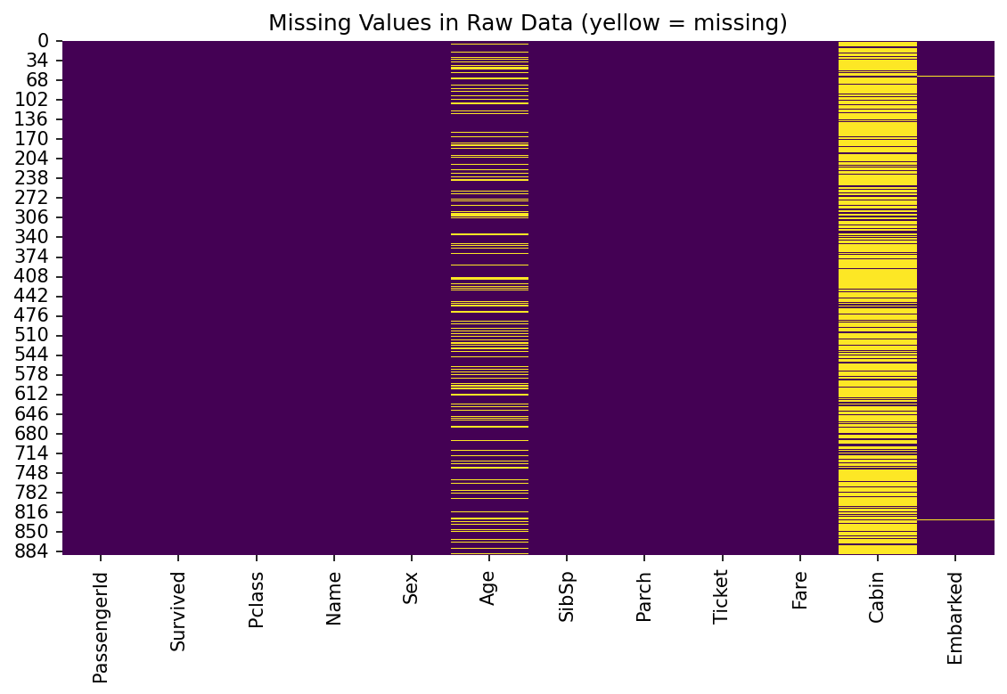
Figure 1: Missing values in the raw dataset (yellow marks a missing entry)
This heatmap shows where data is missing in the raw file before cleaning. Cabin is missing for most rows and Age has scattered gaps throughout. Embarked shows only two thin lines. Every other column is complete. The chart justifies the different treatment used for each column: a column that is mostly empty is dropped, while a column with scattered gaps is imputed.

5.2 Visualization 2: Age distribution
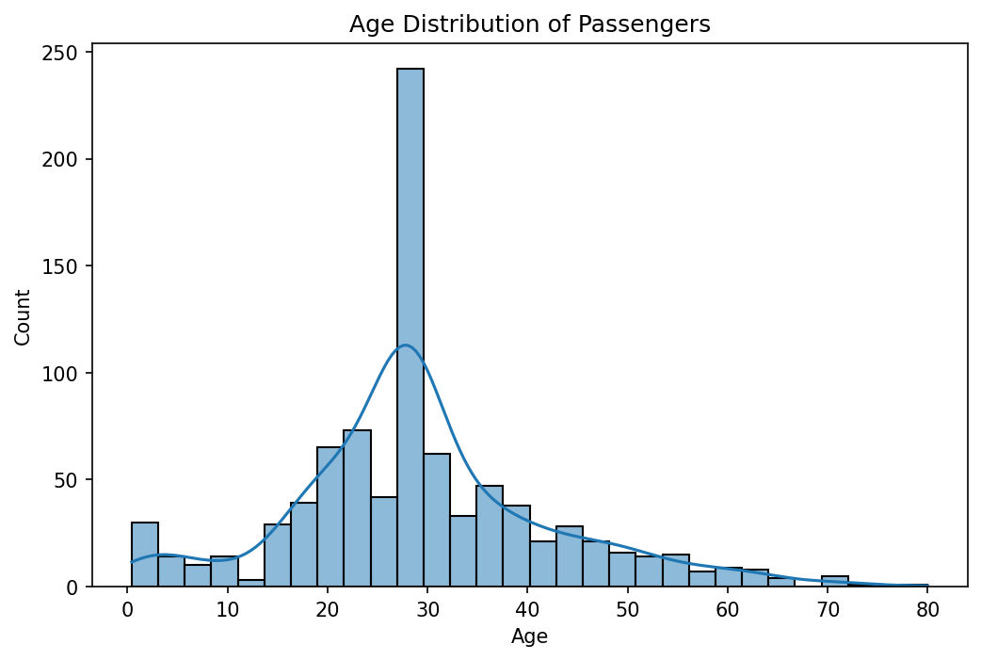
Figure 2: Distribution of passenger ages after cleaning, with density curve
The histogram shows that most passengers were young adults, with the bulk between roughly 20 and 40 years old. There is a smaller group of infants and children and a long thin tail of older passengers up to 80. The tall bar near the middle comes from imputing the 177 missing ages with the median (28), which is a known side effect of median imputation and is worth remembering when interpreting this chart.

5.3 Visualization 3: Fare by survival outcome
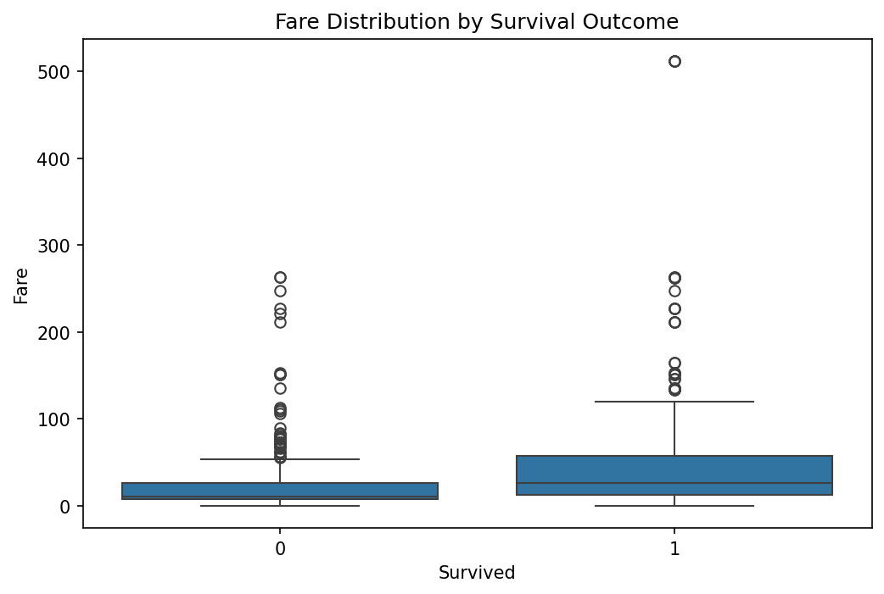
Figure 3: Box plot of fare paid, grouped by survival (0 = did not survive, 1 = survived)
Passengers who survived paid noticeably higher fares. The median fare was 26.00 for survivors compared with 10.50 for non-survivors, and the mean fares were 48.40 and 22.12 respectively. Both groups contain many high outliers, with fares reaching over 500, which confirms the right skew seen in the summary statistics. A box plot was chosen because it shows medians, spread, and outliers together, which suits a skewed variable like Fare.

5.4 Visualization 4: Correlation heatmap
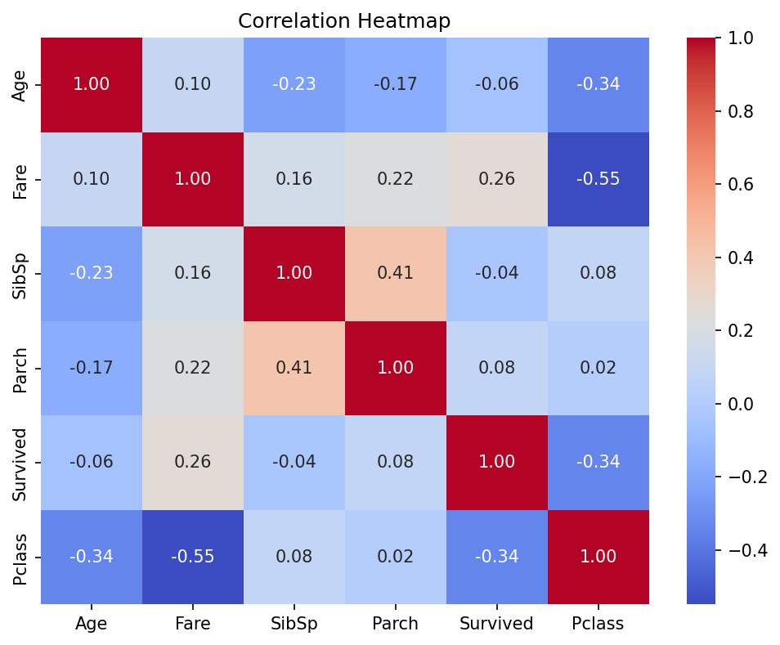
Figure 4: Correlation matrix of numeric variables
The correlation heatmap summarizes linear relationships between the numeric variables. The strongest relationship is between Pclass and Fare (−0.55): a lower class number (higher class) goes with a higher fare, as expected. Survived correlates negatively with Pclass (−0.34) and positively with Fare (0.26), meaning that higher-class, higher-fare passengers were more likely to survive. Age has only a weak link with survival (−0.06). SibSp and Parch are moderately correlated with each other (0.41), which makes sense because they both describe family travelling together. Correlation does not prove cause, and these are simple pairwise values.

6. Summary of Insights
- Data quality was manageable. Only three columns had missing values, and after imputing Age and Embarked and dropping Cabin, the dataset was fully complete with no duplicates.
- Overall survival was 38.4%. Most passengers did not survive.
- Sex shows the largest gap. Women survived at 74.2% compared with 18.9% for men, the most dramatic difference found in the data.
- Ticket class matters. Survival fell steadily from 63.0% in 1st class to 47.3% in 2nd and 24.2% in 3rd class.
- Fare and class tell the same story. Survivors paid higher fares, and fare is strongly linked to class (correlation −0.55).
- Age is weakly related to survival on its own. The correlation with survival is only −0.06, although age may matter in specific groups such as children, which a single correlation cannot show.
- Fare is heavily skewed. A few very high fares distort the mean, so medians or a log transformation are better for later analysis.

7. Areas for Further Analysis
- Test whether the differences in survival by sex and class are statistically significant using chi-square tests (planned for Week 3).
- Create age groups (child, adult, senior) to check whether children had higher survival, since a single correlation coefficient may hide this.
- Engineer a family size feature (SibSp + Parch + 1) and test whether travelling alone or in a small family affected survival.
- Extract passenger titles (Mr, Mrs, Miss, Master) from the Name column, which may offer a better way to estimate missing ages than a single median.
- Create a “cabin recorded” flag to see if having a cabin record relates to survival, instead of discarding the column entirely.
- Apply a log transformation to Fare and compare median-based imputation with group-based imputation (for example by class and sex) for Age.

8. Conclusion
This week’s work covered the first stages of a real data science workflow. The Titanic dataset was acquired from a public source, inspected, and cleaned using clearly justified methods: median imputation for Age, mode imputation for Embarked, removal of the sparse Cabin column, and correction of data types. Exploratory analysis with summary statistics and four visualizations revealed clear patterns: survival differs strongly by sex and ticket class, survivors paid higher fares, and fare is highly skewed. These findings and the questions listed in Section 7 form the basis for the statistical testing, storytelling, and modelling work in the following weeks.

Appendix: Complete Python Script
The full script below reproduces every table value and figure in this report. It requires Titanic-Dataset.csv in the same folder and the pandas, seaborn, and matplotlib libraries.
import os
os.chdir(os.path.dirname(os.path.abspath(__file__)))

import pandas as pd
import seaborn as sns
import matplotlib.pyplot as plt

df = pd.read_csv('Titanic-Dataset.csv')
print("Shape:", df.shape)
print(df.head())
df.info()
print(df.isnull().sum())
print("Duplicates:", df.duplicated().sum())
print(df.describe())

# ---------- CLEANING ----------
# Age: 177 missing -> median imputation
df['Age'] = df['Age'].fillna(df['Age'].median())

# Embarked: 2 missing -> mode imputation
df['Embarked'] = df['Embarked'].fillna(df['Embarked'].mode()[0])

# Cabin: 687 missing (~77%) -> drop column
df = df.drop(columns=['Cabin'])

# Duplicates: check and remove (none found)
df = df.drop_duplicates()

# Correct data types
for col in ['Survived', 'Pclass', 'Sex', 'Embarked']:
df[col] = df[col].astype('category')

print(df.isnull().sum())

# ---------- VISUALIZATIONS ----------
# Visualization 1: age distribution
plt.figure(figsize=(8, 5))
sns.histplot(df['Age'], kde=True, bins=30)
plt.title('Age Distribution of Passengers')
plt.savefig('w1_viz1_age_distribution.png', dpi=150, bbox_inches='tight')
plt.close()

# Visualization 2: missing values (drawn from the RAW data)
raw = pd.read_csv('Titanic-Dataset.csv')
plt.figure(figsize=(9, 5))
sns.heatmap(raw.isnull(), cbar=False, cmap='viridis')
plt.title('Missing Values in Raw Data (yellow = missing)')
plt.savefig('w1_viz2_missing_values.png', dpi=150, bbox_inches='tight')
plt.close()

# Visualization 3: fare by survival
plt.figure(figsize=(8, 5))
sns.boxplot(x='Survived', y='Fare', data=df)
plt.title('Fare Distribution by Survival Outcome')
plt.savefig('w1_viz3_fare_by_survival.png', dpi=150, bbox_inches='tight')
plt.close()

# Visualization 4: correlation heatmap
num = df[['Age', 'Fare', 'SibSp', 'Parch']].copy()
num['Survived'] = df['Survived'].astype(int)
num['Pclass'] = df['Pclass'].astype(int)
plt.figure(figsize=(8, 6))
sns.heatmap(num.corr(), annot=True, cmap='coolwarm', fmt='.2f')
plt.title('Correlation Heatmap')
plt.savefig('w1_viz4_correlation.png', dpi=150, bbox_inches='tight')
plt.close()

# ---------- GROUP COMPARISONS ----------
d = df.copy()
d['Survived'] = d['Survived'].astype(int)
print(d.groupby('Sex', observed=True)['Survived'].mean())
print(d.groupby('Pclass', observed=True)['Survived'].mean())

